**Aim:**

Case study on Fog computing

**Case Study:**

Fog computing is a decentralized computing architecture that extends cloud computing capabilities to the edge of the network, closer to where data is generated and consumed. Here are some key points to explain it:

1. Fog computing is designed to address the limitations of cloud computing, which can be slow and costly due to the need to transfer large amounts of data to and from remote data centers.
2. With fog computing, data processing and storage can be distributed across a network of local devices and cloud resources, enabling faster response times and reduced network traffic.
3. Fog computing uses a combination of local servers, gateways, and edge devices to enable computing resources and services to be deployed closer to the edge of the network.
4. This allows for real-time data processing, reduced latency, and improved security and privacy by keeping sensitive data closer to the source.
5. Fog computing is particularly useful for applications that require low latency, high bandwidth, and high reliability, such as autonomous vehicles, industrial automation, and smart cities.
6. Fog computing is a relatively new concept, and standards for implementation are still being developed by organizations such as the OpenFog Consortium.
7. Despite its benefits, fog computing also poses some challenges, such as the need to manage and orchestrate distributed resources, ensure data consistency and security, and maintain interoperability between different devices and platforms.

Architecture :

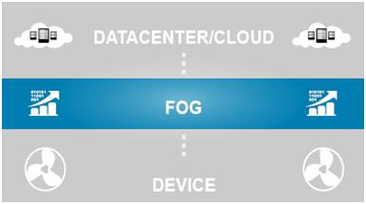

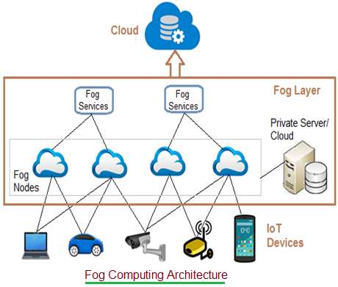

Fog computing architecture:

• IoT devices:

These are devices connected on an IoT network using various wired and wireless technologies. These devices produce data regularly in huge amounts. There are numerous wireless technologies used in IoT which include Zigbee, Zwave, RFID, 6LoWPAN, HART, NFC, Bluetooth, BLE, NFC, ISA-100.11A etc. IoT protocols used include IPv4, IPv6, MQTT, CoAP, XMPP, AMQP etc.

• Fog Nodes:

Any device with computing, storage and network connectivity is known as fog node. Multiple fog nodes are spread across larger regions to provide support to end devices. Fog nodes are connected using different topologies. The fog nodes are installed at various locations as per different applications such as on the floor of a factory, on top of a power pole, alongside a railway track, in vehicles, on oil rigs and so on. Examples of fog nodes are switches, embedded servers, controllers, routers, cameras etc. High sensitive data are processed at these fog nodes.

• Fog aggregate nodes:

Each fog node has their aggregate fog node. It analyzes data in seconds to minutes. IoT data storage at these nodes can be of duration in hours or days. Its geographical coverage is wider. Fog data services are implemented to implement such aggregate node points. They are used to address average sensitive data.

• Remote Cloud:

All the aggregate fog nodes are connected with the cloud. Time insensitive data or less sensitive data are processed, analyzed and stored at the cloud.

• Local server and cloud:

Often fog computing architecture uses a private server/cloud to store the confidential data of the firm. These local storage is also useful to provide data security and data privacy.

**Difference between Cloud computing and Fog computing :**

* Location: The main difference between fog computing and cloud computing is their location. Fog computing brings computing resources closer to the edge of the network, where data is generated and consumed, while cloud computing is centralized and typically relies on remote data centers.
* Latency: Fog computing enables real-time data processing and analysis by reducing the latency of data transfer between devices and servers. Cloud computing can introduce delays due to the need to transfer data to and from remote data centers.
* Scalability: Cloud computing can scale up or down quickly and easily by provisioning additional resources from remote data centers. Fog computing is less scalable than cloud computing but can be more adaptable to changing network conditions.
* Cost: Fog computing can be more cost-effective than cloud computing for applications that require low-latency processing and storage, as it reduces the need for large-scale cloud infrastructure.
* Security: Fog computing can offer improved security and privacy by processing and storing data locally, reducing the risk of data breaches and cyberattacks. Cloud computing can introduce security risks due to the need to transfer data to and from remote data centers.

Advantages of fog computing:

* This approach reduces the amount of data that needs to be sent to the cloud.
* Since the distance to be traveled by the data is reduced, it results in saving network bandwidth.
* Reduces the response time of the system.
* It improves the overall security of the system as the data resides close to the host.
* It provides better privacy as industries can perform analysis on their data locally.